

Vitrek’s 4700 Precision High Voltage Meter adds New HVL-150 SmartProbe™
for Expanded Measurement Range
HVL-150 probe is rated to 140 KVDC / 100 KVAC; features ultra-low temp. coefficient attenuators and low capacitance;
SmartProbe stored precision calibration data assures high accuracy, facilitates interchange with other probes / meters

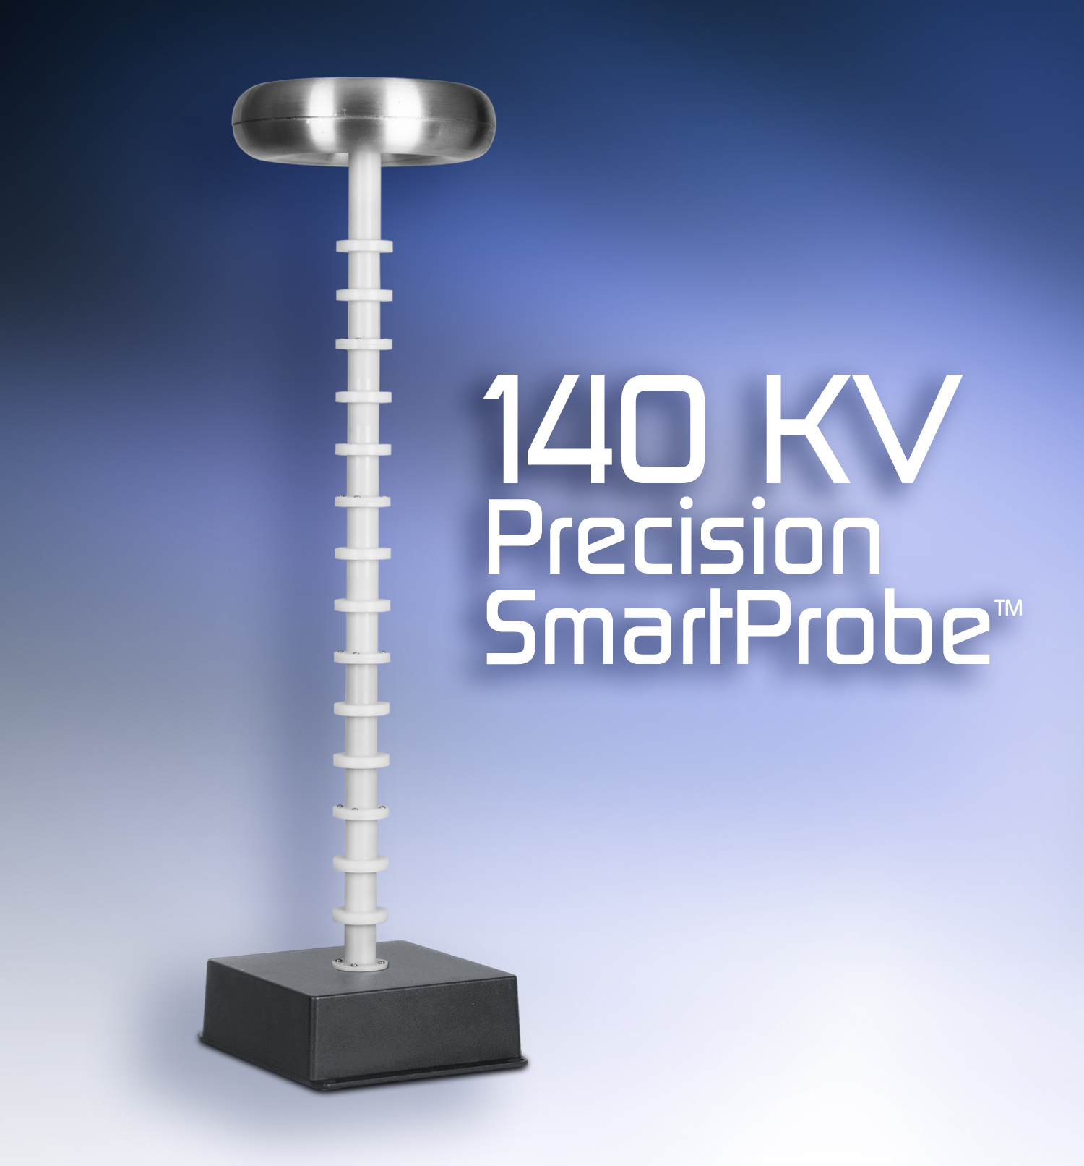
(Click image to download high-res JPEG)
Poway, CA—July 26, 2018—Vitrek, the leader in high-voltage test and measurement equipment, introduces the HVL-150 SmartProbe™ that expands the measurement range of the company’s Model 4700 Precision High-Voltage Meter to 140 KVDC / 100 KVAC(rms). The HVL-150 benchtop probe features Vitrek’s proprietary ultra-low thermal coefficient attenuator technology that minimizes the effects of self-heating to maintain optimum accuracy. In addition, the probe’s low capacitance enhances AC measurement performance.
The Vitrek 4700 HV meter offers high performance while providing instant, direct, high voltage measurement in a portable, compact and rugged benchtop enclosure, outperforming traditional high voltage dividers. The 4700 Precision High-Voltage Meter offers exceptional measurement accuracy (0.03% of reading + 0.03 V) and resolution (10 mV) for direct inputs up to 10 KV. For higher-voltage applications, Vitrek’s SmartProbes are interchangeable and are offered with DC ratings of 35 KV, 70 KV, 100 KV and now, 140 KV. Vitrek SmartProbes store precision calibration data, which is downloaded when plugged into a 4700 HV Meter.
“The 4700 HV meter features a color touchscreen that really makes its operation simple and offers numerical and graphical data display,” said Kevin Clark, Vitrek’s CEO and Chief Technology Officer. “The True RMS AC readings are as true as they come, while the DC measurements offer rocket-fast settling with rock-solid stability.”
To ensure the best possible measurement accuracy, the 4700 High Voltage Meter performs over 40,000 readings per second, which are then filtered, sub-sampled, scaled and offset corrected. The 4700 provides very low frequency AC readings down to 0.01 Hz, as well as peak-to-peak, crest factor and fundamental frequency measurement. Available G series probes offer extremely high input impedances for electrostatic voltmeter applications. Vitrek 4700 HV meters and SmartProbes all come with an ISO 17025 accredited calibration report.

For more information on Vitrek’s 4700 Precision High Voltage Meter click here.
To download a copy of this press release click here.

Price: $2,695. (HV-150 SmartProbe) Delivery: Stock to 2 weeks (ARO)

About Vitrek
Since 1990, Vitrek has provided innovative global solutions for high voltage test and measurement including electrical safety compliance testers, multi-point high-voltage switching systems and graphical power analyzers. Vitrek also supplies precision high voltage measurement standards to national laboratories and calibration labs around the world. This unique combination of capabilities positions Vitrek as a leading provider of test solutions serving the photovoltaic, medical equipment, power conversion, electrical component and appliance industries.

Company Contact:
Kevin Clark, CEO
Vitrek, Inc.
858.689.2755 x202
kclark@vitrek.com

www.vitrek.com
Agency Contact:
Greg Evans • Acct. Exec.
WelComm, Inc.
Direct: 858-633-1911
greg@welcomm.com
www.welcomm.com

