
New Vitrek Website Presents Comprehensive Details of Company’s
Test & Measurement Product Portfolio
Interactive menus provide easy access to products by type and application: test & measurement instruments, high-speed data acquisition & signal recording, metrology, signal simulation, and jet engine vibration testing systems
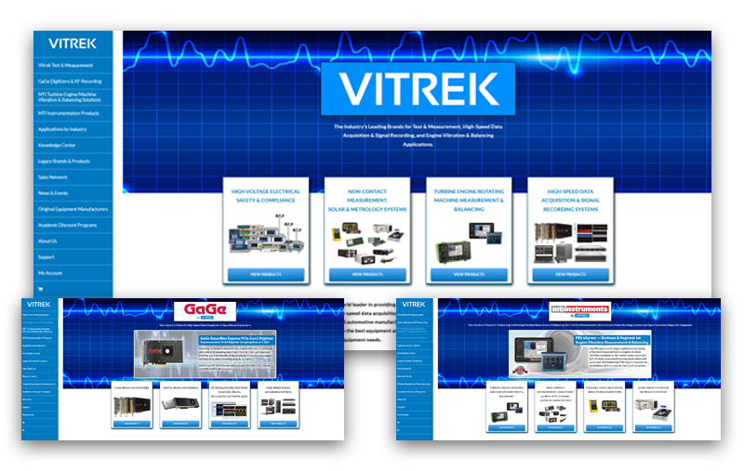
Poway, CA—August 10, 2023—Vitrek, a major manufacturer of precision electrical safety testing equipment, high-speed data acquisition and signal recording, and advanced metrology and simulation instruments and systems, announces the launch of its fully redesigned and expanded website. The new website at vitrek.com provides easy navigation of the company’s extensive product portfolio. Its intuitive menu selection presents solutions by type, specific application and by signature brand (Vitrek, MTI Instruments and GaGe).
“Vitrek offers a unique selection of test and measurement instruments used in an exceptionally wide range of industries,” said Don Millstein, Vitrek’s President and CEO. “Our new website has been designed to allow efficient access to our products, either by type or by application. Visitors who want to find Vitrek, MTI or GaGe products by their particular brand will find fast and relevant results.”
The organization of the Vitrek homepage allows visitors to quickly drill down to find the information needed. Top-level tabs include:
- Vitrek Test & Measurement: Hipot testers, power analyzers, electronic loads and hi-voltage instruments
- Gage Digitizers & RF Recording: Hi-speed digitizers, digital signal processors, signal recording systems
- MTI Instrumentation and Turbine Engine Machine Vibration & Balancing Systems: Measurement and analysis, signal simulators, charge amplifiers, metrology systems
- Industry Applications: Products by aerospace, semiconductor, medical, automotive and many other industries
- Knowledge Center: A compendium of news releases, educational articles and video tutorials
- News & Events: The latest product announcements, webinars and trade shows
- Sales Network: A complete directory of Vitrek’s global sales support network
The homepage also offers direct links to Academic Discount Programs (Vitrek, MTI, GaGe) and Original Equipment Manufacturers (MTI OEM Capacitance Products, GaGe OEM Program). Navigation upgrades include a comprehensive search, account sign-up as well as a shopping cart for online purchases with an option for expedited shipping.
“I invite all of our users to experience the new website where they can quickly and easily navigate to any product information or application note with ease,” said Don.

About Vitrek
Since 1990, Vitrek has provided innovative global solutions for high voltage test and measurement including electrical safety compliance testers, multi-point high voltage switching systems and graphical power analyzers. Vitrek is the parent company of several industry related brands, including XiTRON, MTI Instruments, GaGe, Signatec and KineticSystems. Our portfolio of products include test and measurement solutions including high-voltage, safety and compliance testing solutions, non-contact measurement devices, portable signal simulators and calibrators, semiconductor/solar metrology systems and turbine engine/rotating machine balancing. Our data-acquisition brands add a wide array of board-level data acquisition and integrated real-time signal recording system solutions from GaGe, Signatec, and KineticSystems. Vitrek also supplies precision high voltage measurement standards to national laboratories and calibration labs around the world. This unique and complementary combination of product and engineering capabilities positions Vitrek as a leading provider of test solutions serving the photovoltaic, medical equipment, power conversion, electrical/electronic component, semiconductor, aerospace and appliance industries. Vitrek is an accredited ISO 17025 Calibration Laboratory and ISO 9001:2015 Certified organization.

Company Contact:
Suzy Abbott, Marketing Manager
Vitrek, Inc.
858.689.2755

suzy.abbott@vitrek.com

www.vitrek.com

Agency Contact:
Greg Evans • Acct. Exec.
WelComm, Inc.
Direct: 858-633-1911
greg@welcomm.com
www.welcomm.com

